**DECIMAL TO OCTAL CONVERSION**

**EXP NO: 29**

**AIM:**To write a C program to implement decimal to octal conversion.

**ALGORITHM:**

1. Store the remainder when the number is divided by 8 in an array.
2. Divide the number by 8 now
3. Repeat the above two steps until the number is not equal to 0.
4. Print the array in reverse order now.

**PROGRAM:**

#include <stdio.h>

int

main()

{

long decimal, remainder, quotient,octal=0;

int octalnum[100], i = 1, j;

printf("Enter the decimal number: ");

scanf("%ld", &decimal); quotient = decimal;

while (quotient != 0)

{

octalnum[i++] = quotient % 8;

quotient = quotient / 8;

}

for (j = i - 1; j > 0; j--) octal= octal*10 + octalnum[j];

printf("Equivalent octal value ofdecimal no %d is: %d ", decimal,octalnum); return 0;

}

**INPUT &** **OUTPUT:**

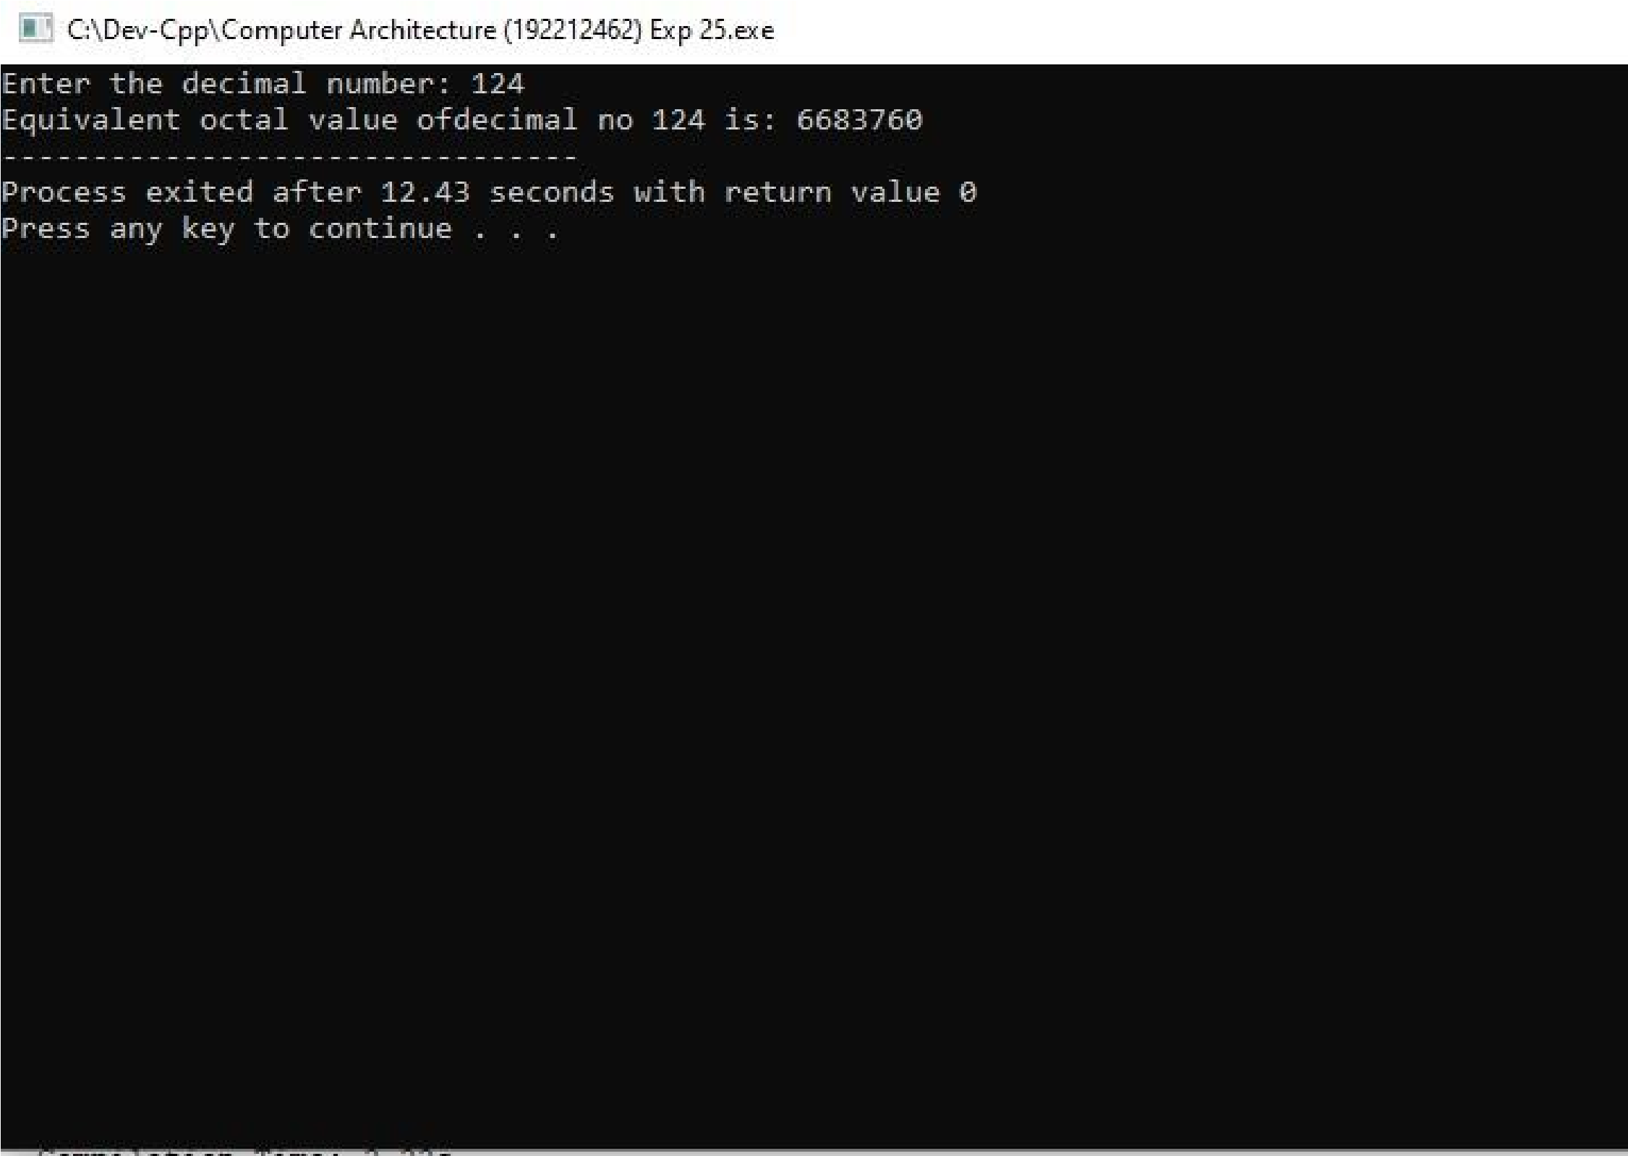

**RESULT:** Thus the program was executed successfully using DevC++.